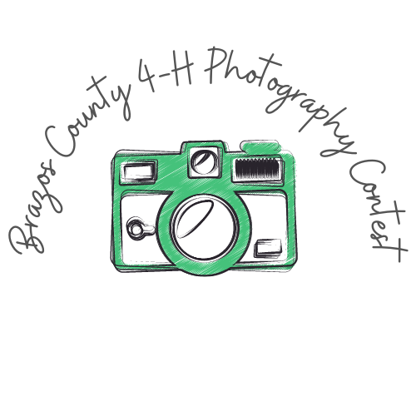
TEXAS YOUNG FARMERS PHOTOGRAPHY CONTEST SUBMISSION FORM
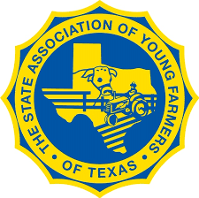
Complete form and submit with each entry

Name: __________________________ Chapter: ________________________

You will be allowed to submit one picture per category, per paid member is allowed. Each picture should be classified by the member submitting the picture. The categories are:
# | Category | Description | X
1 | Agriculture at Work | People involved in agricultural tasks
2 | Agriculture at Leisure | People involved in recreational time activities
3 | Agriculture Animals | Domesticated animals and no people
4 | Agriculture Equipment | Pictures of Ag equipment and no people
5 | Agriculture Landscape | Pictures of landscape with no people, animals or equipment
6 | Agriculture Wildlife | Pictures that include non-domesticated wildlife
7 | Agriculture Future | Pictures of young people involved in Ag activity age 12 and under

Pictures are due by January 2nd, 2021.
Email your picture and form to slmende63@gmail.com
Pictures must be in one of these formats: .jpeg, .jpg or .gif

Winners will be announced at the Texas Young Farmers Convention on January 9th, 2021

All pictures must be from Texas.
If the judge determines that the picture is not in the correct category, it will not be judged.
**By submitting your picture in this contest, you are allowing the use of your photo to be displayed in the Texas Young Farmer Newsletters and the Texas Young Farmer Facebook Page unless otherwise indicated.

