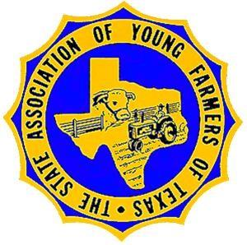

The State Association of Texas Young Farmers of Texas is a 501c3 educational organization EIN#74-6084259. Main office address is 614 E 12th Street, Austin TX 78701. All communication should be sent to Executive Secretary at address in letterhead.

Supporting Texas Young Farmers Scholarships,﻿ one auction item at a time!

It's the most wonderful time of the year! We are excited to gather once again at the annual State Young Farmers Convention in Huntsville Texas, January 12-15, 2023, with all of you. Through the conference, we can come together as members to learn together, network together and strengthen our industry together.

As the chair of this year's auction, I am personally reaching out to ask for your support! With donations from our members, exhibitors, and sponsors, we can raise funds to continue to provide scholarships for our young farmers students.

This year we will feature an online auction and live auction.

As we get closer to the event, we still need your help! Here are a few ways on how you can contribute:

·    Donate an auction item

Donations can include gift baskets, event tickets, gift cards or certificates, hand crafted goodies, Hunting trips, Fishing trips and so much more! To donate an item contact Sherry Free at [admin@pasadenarodeo.com](mailto:admin@pasadenarodeo.com) or 281-487-0240

Online bidding and Register information coming soon.

On behalf of the auction committee, thank you for your continued support and will see you soon!

Board of Directors

President

Makayla Donaldson

President Elect

L.A. Muehr

Past President

Herb Casey

VP Area I

Barry Choate

VP Area II

Seth Kiker

Kenneth Hedrick

VP Area III

Sherry Free

VP Area IV

Charles Rochester

VP Area V

Ethel Rochester

VP Area VII

Tommy Ketchum

VP Area VIII

Kenny Bulger

VP Area IX

VP Area X

Dillon Donaldson

VP Area XI

Charlie Rochester

VP Area XII

CJ Johnson

Advisor

Terry Hausenfluck

Executive Administrator

Ray Pieniazek

Executive Secretary

Sandra Choate

The State Association of Young Farmers of Texas

10150 CR 1307

Malakoff, TX 75751

www.txyoungfarmers.org

txyfaes@gmail.com

903-286-0520